|  |
| --- |
| IN COLLABORATION WITH |
| **Magic Strikes** |
| **A Unity 3D Maze Game** |
| Version #2.0  All work Copyright © 2016  by  Bluesky Studios  &  Wimowomi Innovations.  All rights reserved. |
| **Angela Liu & Sara Womiloju** |
|  |

****

|  |
| --- |
| November 23, 2016 |

Table of Contents

[Version History 3](#_Toc467609342)

[Game Description 4](#_Toc467609343)

[**I.** **Game Overview** 4](#_Toc467609344)

[***II.*** **Camera** 5](#_Toc467609345)

[**III.** **Controls** 5](#_Toc467609346)

[**IV.** **Interface Sketch** 5](#_Toc467609347)

[a. Initial Wireframe of game design 5](#_Toc467609348)

[**V.** **Characters** 9](#_Toc467609349)

[***VI.*** **Enemies** 10](#_Toc467609350)

[**VII.** **Items** 10](#_Toc467609351)

[**VIII.** **Scoring** 10](#_Toc467609352)

[**IX.** **Sound Index** 10](#_Toc467609353)

[**X.** **Art / Multimedia Index** 11](#_Toc467609354)

[**XI.** **Future Features** 13](#_Toc467609355)

[References 14](#_Toc467609356)

# Version History

Github Link: <https://github.com/saradoubleu/3D_Game>

Version 2.0

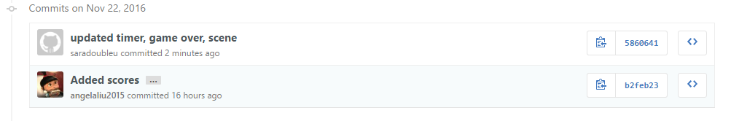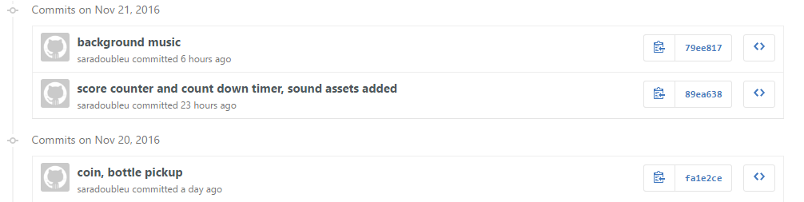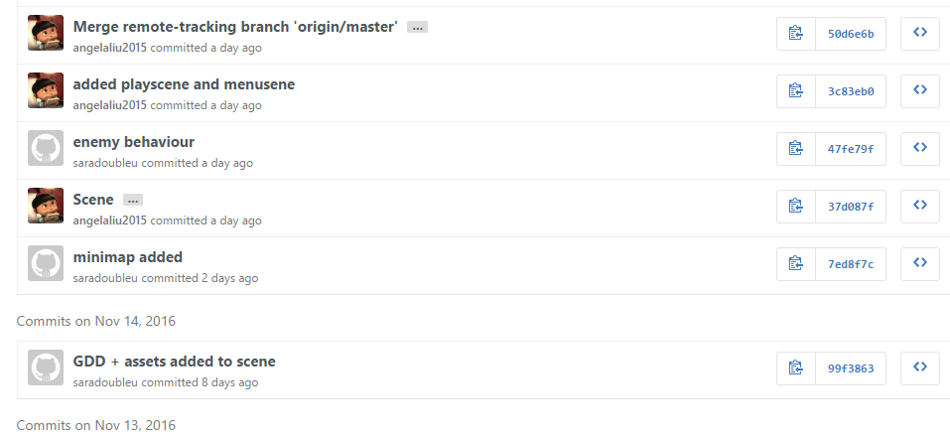



Version 1.0

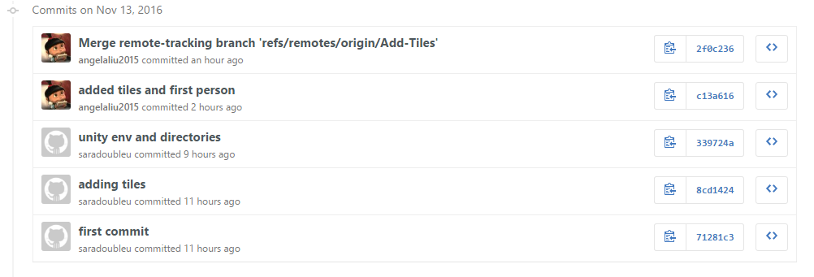

# Game Description

1. **Game Overview**

This first person player game has you (the scientist) running through town collecting coins and potions while avoiding collisions with mummies that chase you.

In order to win the game, the player must collect three magical bottles of potions scattered throughout town before time runs out.

The player loses if they run out of time, if the health level falls below 0 or if they do not collect all 3 bottles before the time runs out.

1. **Camera**

*The camera for this game uses a first person perspective from the players point of view.*

1. **Controls**

To control and navigate the first person player, the WASD keys or mouse movement can be used for player movement. Additionally, the space bar can be pressed allowing for multiple jumps.

1. **Interface Sketch**
2. Initial Wireframe of game design

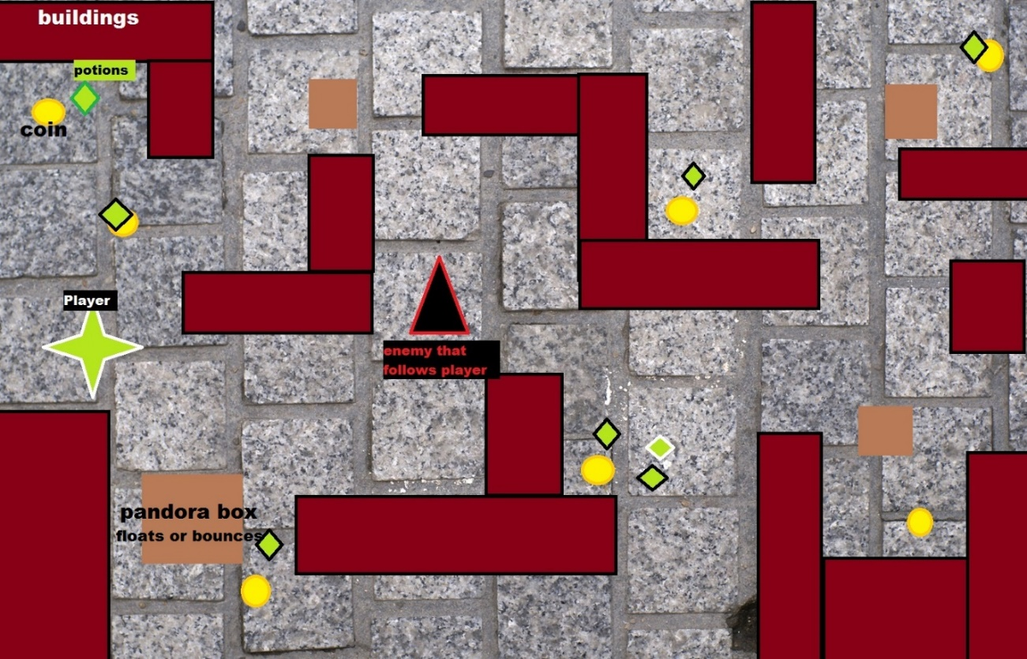

1. **Final Game Design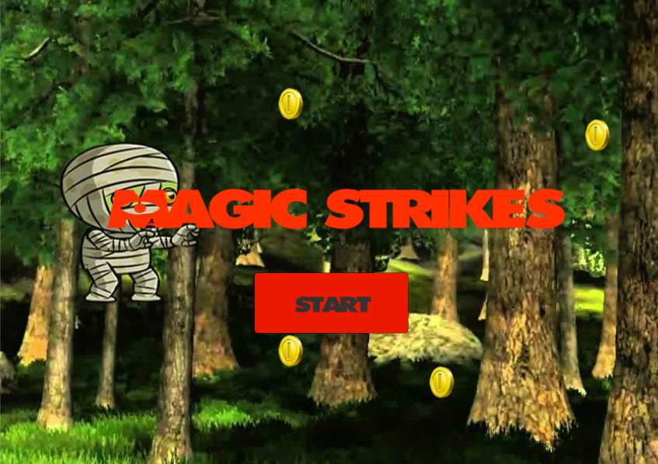**

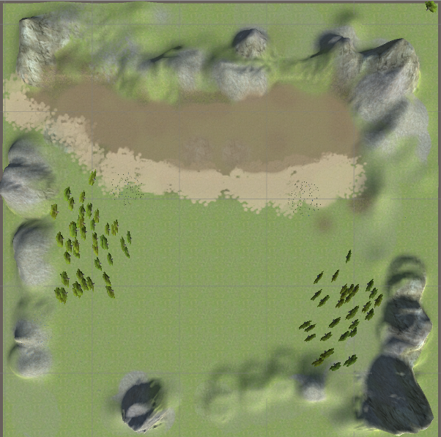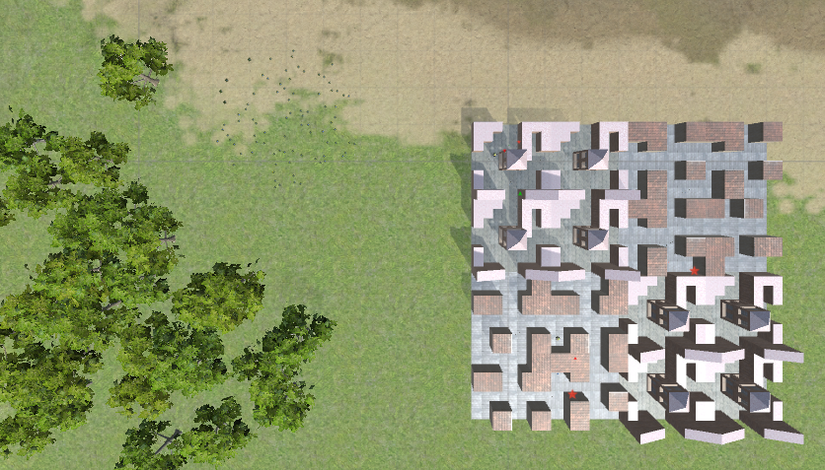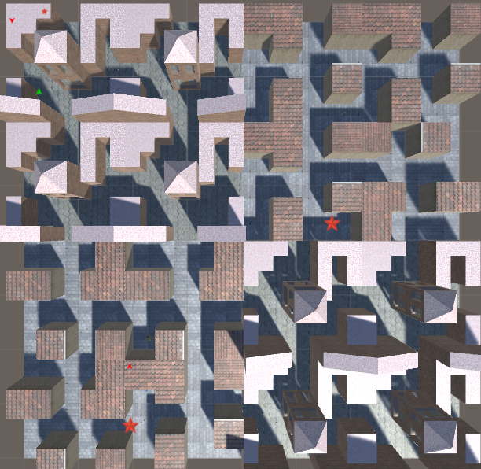

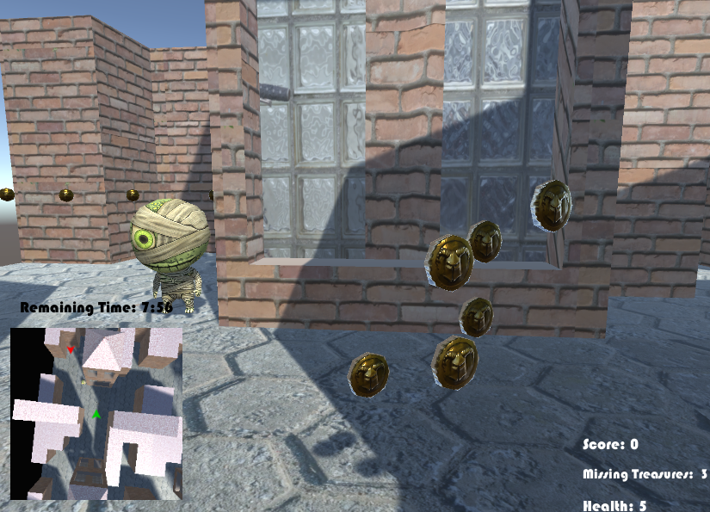

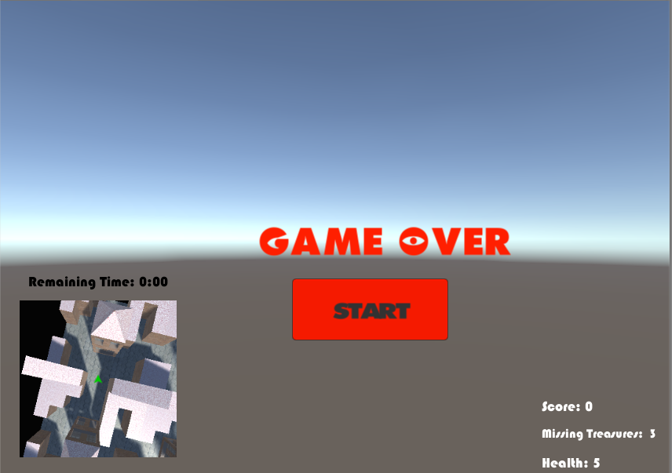

1. **Characters**

The first person character can walk, jump or stand idle. Being a first person character, they can also rotate, or pivot to look up or down.

1. **Enemies**

**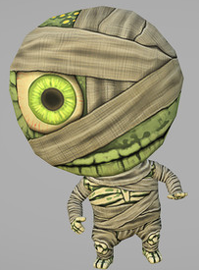**The only enemy in the game is a mummy that follows the player as they navigate through the streets. Each collision decreases the player’s Health status.

1. **Items**

The player can pick up coins worth 1 point each. Additionally, they can locate 3 hidden treasures which are the potion bottles.

**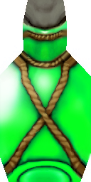**

1. **Scoring**

The player is able to collect coins which equates to 1 score point. Additionally, they lose a health status point with each enemy collision.

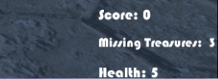

1. **Sound Index**

|  |  |  |
| --- | --- | --- |
| **Name** | **Sound Clip** | **Details** |
| Picked Coin Echo 2 |  | Pickup coin |
| Jingle\_Achievement\_01 |  | Pickup bottles |
| Ouch0 |  | Collision with enemy |
| Battle in winter |  | Background theme song |
| GameOverSound |  | End of Game theme song |

1. **Art / Multimedia Index**

|  |  |  |
| --- | --- | --- |
| **Name** | **Image** | **Details** |
| Chibi mummy | **C:\Users\sara womi\AppData\Local\Microsoft\Windows\INetCache\Content.Word\mummy.png** | Enemy |
| Bottles | **C:\Users\sara womi\AppData\Local\Microsoft\Windows\INetCache\Content.Word\Bottle_blue_diff.pngBottle_red_diffBottle_green_diff** | Health |
| Coin | **C:\Users\sara womi\AppData\Local\Microsoft\Windows\INetCache\Content.Word\Coin_diffuse.png** | Points |
| En\_arrowd | **C:\Users\sara womi\3D_Game\3D_Game\Assets\Textures\en_arrowd.png** |  |
| plyr | **C:\Users\sara womi\3D_Game\3D_Game\Assets\Textures\plyr.png** |  |
|  | **C:\Users\sara womi\3D_Game\3D_Game\Assets\Textures\star.png** |  |
| Mummy | **C:\Users\sara womi\3D_Game\3D_Game\Assets\Textures\Mummy.png** |  |
| BrickBrown | **C:\Users\sara womi\3D_Game\3D_Game\Assets\Textures\BrickBrown.jpg** | Maze Tile wall |
| Crackles | **C:\Users\sara womi\3D_Game\3D_Game\Assets\Textures\Crackles.jpg** | Maze Tile Roof |
| FloorsMarble | **C:\Users\sara womi\3D_Game\3D_Game\Assets\Textures\FloorsMarble_N.jpg** | Maze Tile Floor |
| MedievalBrick | **C:\Users\sara womi\3D_Game\3D_Game\Assets\Textures\MedievalBrick.jpg** | Maze Tile Roof |
| MedievalRoof | **C:\Users\sara womi\3D_Game\3D_Game\Assets\Textures\MedievalRoof.jpg** | Maze Tile Roof |
| MedievalStreetTexture | **C:\Users\sara womi\3D_Game\3D_Game\Assets\Textures\MedievalStreetTexture.jpg** | Maze Tile Ground |
| WindowBlocks | **C:\Users\sara womi\3D_Game\3D_Game\Assets\Textures\WindowsBlocks.jpg** | Maze Tile Window |

1. **Future Features**

Future implementations for this game will include levels that increase with difficulty. Each level would have a shorter time span and more enemies to fend off. Additionally, the physical structure will have different levels that the user can climb also increasing the complexity.

# References

<http://opengameart.org/>

<http://www.textures.com/>

<http://www.turbosquid.com/3d-models/jfk-dollar-max-free/601669>

<https://www.assetstore.unity3d.com/>